Angles

In the first column are some key words that you need to know the meaning of. The second column contains the meanings of these words, and the third column a diagram to match the description. However, all the meanings have been jumbled up. Cut out each box, and stick them into your book so that the meanings and diagrams match the word.

Acute angle | The unit for measuring angles | °
Obtuse angle | An angle between 180° and 360° | 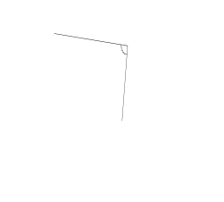
Reflex angle | An angle of 90° | 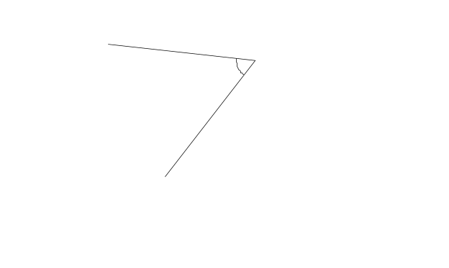
Degrees | An angle between 90° and 180° | 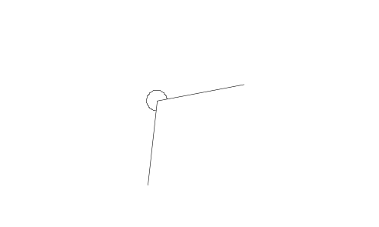
Right angle | An angle smaller than 90° | 